

Master der Geoinformatik

Geo 450 GRASS GIS

**Combining the Function of mask (Fmask) algorithm and GRASS GIS with Sentinel-2 data**

**Studenten:**

Florian Hellwig

Veronika Grupp

Robin Kohrs

**Lehrende:**

John Truckenbrodt

Martin Landa

Juli 2020

# Table of Contents

### [1 Project Outline (Vroni) 3](#__RefHeading___Toc2256_1013033740)

### [2 Data and Software 4](#__RefHeading___Toc2258_1013033740)

[2.1 Sentinel 2 (Flo) 4](#__RefHeading___Toc2260_1013033740)

[2.2 GRASS GIS and Python (Robin) 4](#__RefHeading___Toc2262_1013033740)

### [3 Working process 5](#__RefHeading___Toc2264_1013033740)

[3.1 Data Download (Vroni) 5](#__RefHeading___Toc2266_1013033740)

[3.2 Data Preprocessing (Vroni) 7](#__RefHeading___Toc2268_1013033740)

[3.3 Fmask Cloud Filtering (Robin) 7](#__RefHeading___Toc2270_1013033740)

[3.4 Post-Processing of results: 9](#__RefHeading___Toc2272_1013033740)

[3.5 Import to GRASS 10](#__RefHeading___Toc2274_1013033740)

[3.6 Creation of Space Time Cubes (Vroni) 10](#__RefHeading___Toc2276_1013033740)

[3.7 Multi-temporal index calculation (Flo) 11](#__RefHeading___Toc2278_1013033740)

[3.8 Web Processing Service 11](#__RefHeading___Toc2280_1013033740)

### [4 Discussion/Conclusion 12](#__RefHeading___Toc2282_1013033740)

### [5 References 13](#__RefHeading___Toc2284_1013033740)

### [7 Appendix 14](#__RefHeading___Toc2286_1013033740)

# Project Outline (Vroni)

This report documents the project work following a one week course on remote sensing data processing with GRASS GIS by Martin Landa on 10.-14.02.2020 in Jena.

The aim of our work package was to create a space time data cube based on Sentinel 2 scenes for the Jena-Roda test site in Thuringia and to provide a PyWPS (Python based Web Processing Service) to produce temporal aggregations and vegetational change indices. We used Python scripts as well as the Python Application Programming Interface PyGRASS to accomplish those tasks.

Sentinel 2 data was downloaded in different processing levels to create cloud masks with the functional mask algorithm (hereafter Fmask) and to fill the space time cube (hereafter: STC) with atmospherically corrected data. Although projected, we decided not to complete the development of a GRASS GIS add-on to incorporate the Fmask algorithm into GRASS GIS because of various problems regarding different python and GRASS GIS distributions as well as different operating systems. Nevertheless, we applied the Fmask algorithm to the downloaded scenes and the resulting cloud masks were integrated into the space time data cube to exclude the respective areas. The dataset served as the basis for spatio-temporal index calculations which were executed locally and also provided as PyWPS. In the following we will introduce the data and software used and describe the performed processing steps more detailed.

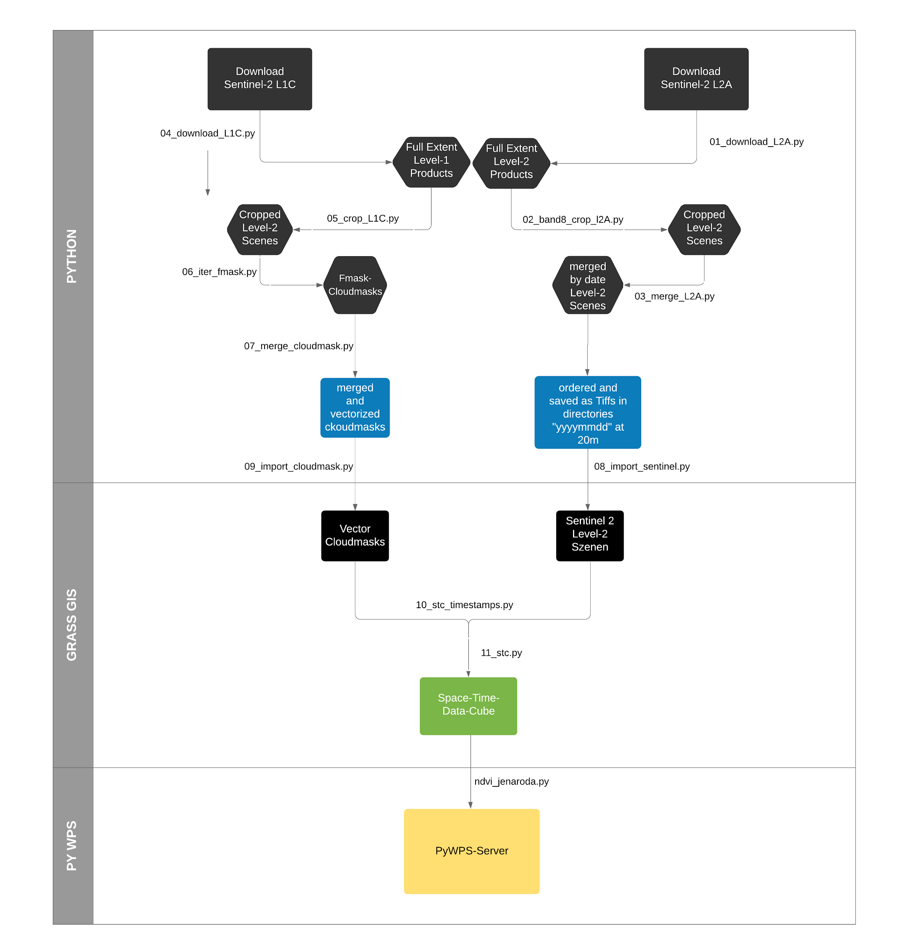

**Fig: 1, Flowchart of the our process**

# Data and Software

## Sentinel 2

Technical Info on Sentinel 2, our AOI, which scenes we downloaded and why (proccessing level, dates, no own atmo correction because too computationally and time-intensive)

## GRASS GIS and Python

As many other geospatial software products, GRASS has a very close connection to the python programming language. There are several libraries that connect in one way or another python and GRASS (Landa 2020, GRASS-Development Team, 2019). There even exists a python shell already implemented in GRASS which enables the user to directly run little python scripts in the GRASS-Gui.

The two main APIs used in our workflow were the GRASS scripting API and the PyGRASS API. While the more basic scripting API allows for launching GRASS modules in a typical python script, the PyGRASS approach offers python access to the low level GRASS C API in an object-oriented way (GRASS-GIS, 2019). For beginners this bares huge potential to get a little lost in the way you are interacting/speaking to the GRASS. In one can distinguish between the possibilities to use GRASS through python without explicitly starting a GRASS session and the simpler and more common way, of using GRASS from within a GRASS session (GRASS-wiki, 2020).

In our workflow we not exclusively used GRASS functionalities. Moreover, we relied on some features that python and it’s own extensions offer. To name two examples: In order to download the Sentinel-2 data we wrote a script that uses the sentinelsat-package. Although the i.sentinel.download add-on in GRASS also uses this module, it was not compatible with some of our GRASS installations. We also faced issues in cropping and merging the image-files produced by the python-fmask. While this probably would be possible in GRASS, we also decided to do this without using GRASS-functionalities as there are some packages that facilitate these types of operations. Especially the numpy-package, which has enormous capabilities in multidimensional linear algebra, and rasterio helped us to overcome these challenges.   
  
The software used for each step in our workflow is schematically displayed in figure 1. Although it gives the appearance of clear cuts between each step and software, it’s in the nature of the process that there are more connections than visualized here.

# Working process

## Data Download

The download of Sentinel-2 scenes was divided into two separate processes since L1C processing level is required for cloud mask filtering with fmask and for index calculation atmospherically corrected data is needed. Due to limited available computational power we decided to download pre-processed data (Level L2A) instead of performing atmospheric correction ourselves (see chapter xy).

Sentinel 2 data is provided by ESA through the Copernicus Open Access Hub ([https://scihub.copernicus.eu/dhus/#/home](https://scihub.copernicus.eu/dhus/" \l "/home)). For the download we used the Python package *sentinelsat* which offers a Python API to the Open Access Hub (<https://github.com/sentinelsat/sentinelsat>). Thesentinelsat package is also available in GRASS GIS through the i.sentinel.download add-on, however the following processing steps were performed in plain Python and for certain GRASS GIS distributions the add-on did not work.

Sentinelsatenables searching and filtering available satellite imagery based on different criteria. Our region of interest was covered by two scenes of the relative orbit number 065 with tile numbers T32UQB and T32UPB (see figure xy). As only a fraction of the two scenes was needed we cropped the image to reduce computational effort (see chapter xy). Still the tiles had to be downloaded as a whole in the first place. As we had limited storage available we confined our search to the last year from the current date. Moreover satellite images are accessible without delay only for 12 (L1C) or 18 (L2A) months after the sensing date on the Open Access Hub. They are then moved to the long term archive and can’t be accessed instantly (ESA LTA User Guide Website). The search was delimited to scenes with a cloud cover of up to 10%. Altogether 22 images for 11 dates between June 2019 and May 2020 were downloaded. The initial search and download was performed with L2A scenes, the L1C data was downloaded subsequently based on the chosen dates in the L2A process. The download procedure was the same for both processing levels. In the sentinelsatarchitecture first a query with search criteria is sent to the Open Access Hub. The query yields a list of available scenes matching the given criteria that is used for the download command. The data is only accessible for registered users, so for the query as well as the download login credentials are required. L2A data was downloaded first and preprocessed (see chapter xy). The resulting folder structure was used to extract the chosen sensing dates. Based on these dates L1C scenes were queried and downloaded. (see Python scripts for L2A and L1C download)

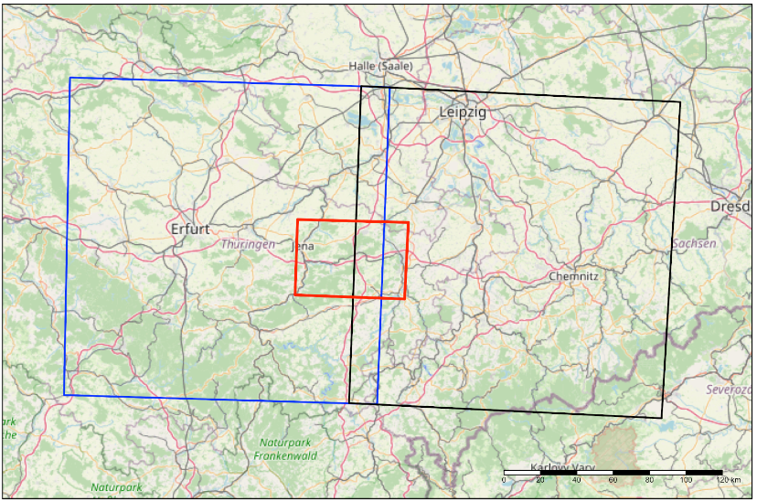

**Fig: 2, Jena Roda test site, the area of interest of this work (red bounds), is covered by two Sentinel 2 data tiles (T32UPB with blue bounds, T32UQB with black bounds). (Map created with R tmap (tmap Quelle), map data copyrighted OpenStreetMap contributors and available from https://www.openstreetmap.org.)**

## Data Preprocessing

After the download the L2A as well as the L1C level scenes were cropped to their overlap with the area of interest. The Sentinel-2 data is provided in a folder structure called .SAFE directory which stores image as well as different metadata. For the Fmask cloud filtering this folder structure had to be preserved as it is the required input format. Therefore, the script for cropping the scenes (name of the script) included walking through the directories and cropping the individual bands. Cropping was performed with the rasterio.mask.mask function which takes a raster object as well as a polygon/shape and crops the raster to the extent of the shape. Original image files were overwritten by the cropped ones (script name). As L2A data comes in different spatial resolutions the script for this processing level was slightly modified and confined to data with 20 m resolution (script name). The near infrared band (band 8) which is needed for NDVI and other vegetational indizes is delivered by ESA in a spatial resolution of 10m. It was therefore resampled to 20m to build a consistent dataset (Skript).

To create a comprehensive space time data set and avoid duplicated index results (see overlap of Sentinel scenes in figure xy within the area of interest) the two scenes for each day were merged. This was achieved by a subprocess call to gdal’s merge command for each of the bands. Thereby the original .SAFE folder structure was dissolved and the bands of each of the merged scenes were stored in a folder named after the respective sensing date. The raster file format was changed from JPEG 2000 to Geotiff and original file names were shortened keeping only the relevant information (foremost the date) for the following steps (script name).

## Fmask Cloud Filtering

The functional mask algorithm is an algorithm developed by Zhu and Woodcock (2012) at the Boston University. Originally it was launched as a cloud and shadow detection algorithm for Landsat TM images.

In 2015 the authors updated the software and included the Landsat 8 TM. Moreover, a prototype algorithm for the Sentinel-2 mission was incorporated. However, the Sentinel-2 satellite doesn’t come with a thermal band, which would further help to identify clouds. It turned out that the cirrus band in Sentinel-2 led to even more accurate estimates of cloud probabilities than the ones produced for Landsat 4-7. The best accuracy was achieved with Landsat 8 imagery. The authors concluded that: “[...] the new Fmask algorithms designed for Sentinel 2 and Landsat 8 are promising.” (Zhu et al. 2015, S:276).

While there were made more improvements in the algorithms (Qiu et al. 2017, Qiu et al. 2019) one major contribution for our work was the implementation of the algorithm in the python programming language. This development was mainly led by Neil Flood and the first commit on the official githu-repository was made in september 2015 (<https://github.com/ubarsc/python-fmask>). The python-fmask package is not yet installable via pip. However, conda offers an easy way to install the package in a conda user-environment. Once downloaded and installed, the package automatically sets some environment variables. This straight-forward process enables the user to run a one-line command to produce cloud-masks for a Sentinel-2 .SAFE-directory only minutes after installing.

In Figure 3 one can see that the Fmask-algorithm performs better in this scene than the cloud mask layer delivered from the ESA. However, and without any proper validation, we couldn’t observe this result with all our processed scenes. The discrepancy and miss-match in the Fmask-algorithm in some images was astonishing high. After all, this can also be due to us as semi-experienced users of the algorithm. As an example the scene from the 17th of January 2020 in figure 4 highlights these differences. It’s not clear to this point what the cause of this extreme overestimation of clouds in that image is.

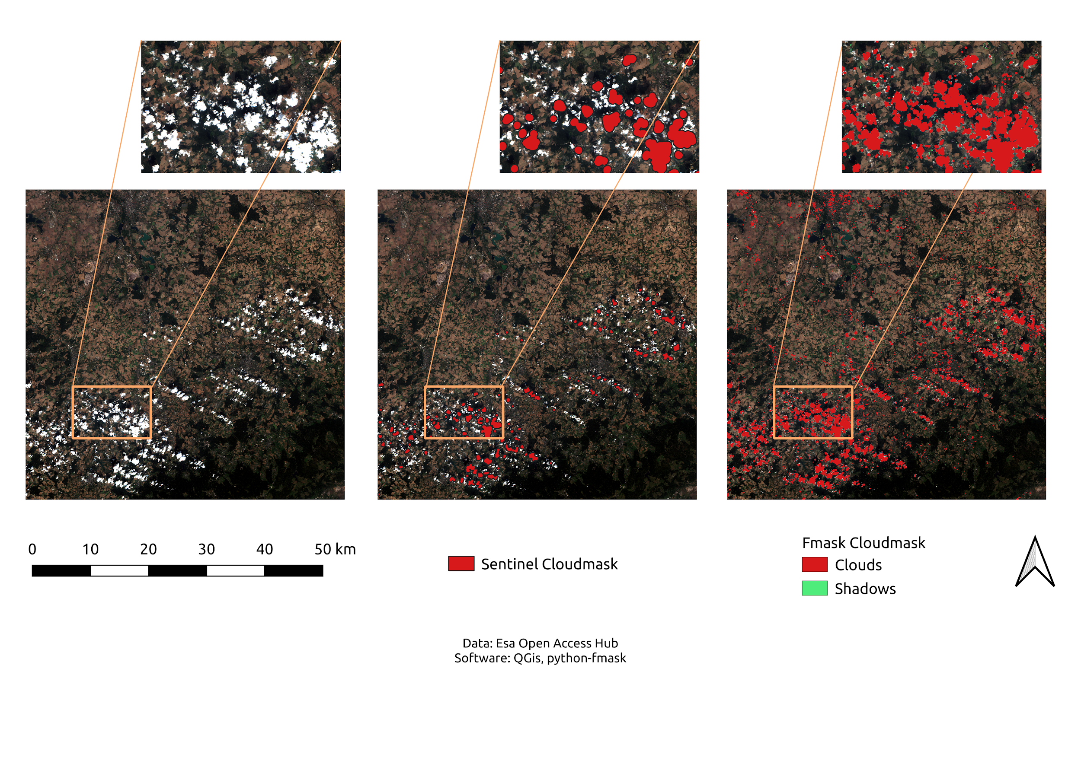

**Fig: 3, Comparison of ESA’s Sentinel-2 cloudmask (middle) and the Fmask-cloudmask (right)**

The cloud masks that finally were imported into GRASS Gis are the result of the Fmask-Algorithm applied on spatially cropped Sentinel-2 scenes. This additional preprocessing step was done in order to further reduce the processing time. We also tried to implement a “parallelization”-approach as this seems a suitable task for this, but didn’t yet succeed.

All these steps, including the download of Sentinel-2 MSI1C, the Fmask-Algorithm, the consequent import into GRASS and some other steps were planned to be written as a GRASS-Gis add-on. This would have included a little GUI and no need for the user to enter any command line options. This was one of the main goals and the corresponding time was put into this. Finally, we didn’t manage to create the add-on. The main problem was the relation and dependency between GRASS and python. It’s very possible that there is some way to make this work. However, as python-fmask is only installable via conda we didn’t find a solution so that GRASS would use the same python-interpreter as the python-fmask and still continue running. We tried to create symlinks with links to the conda-python, we modified the PATH, PYTHONPATH and GRASS\_PYTHON environment variables, we also installed Fmask from source into a different location. Nevertheless, none of these options worked and help on the internet was rare. What initially was though to be something similar to the architecture and idea of sentinelsat in GRASS, turned out to be way more complicated for us. The message: “ModuleNotFoundError: No module named 'fmask'” was probably one of the most read sentences throughout this project.

Important to mention is also that Fmask takes Top of Atmosphere images as input, whereas most index-calculations, like the ndvi, require Bottom of Atmosphere data. This seems to be an easy to solve problem. Still, none of the algorithms for atmospheric correction worked on the amount of scenes downloaded on our local machines in a reasonable time. What we did instead was to download the L2A, Bottom of Atmosphere products, from the Sentinel-Hub page.

## Post-Processing of results

The Fmask algorithm yields a raster file with the extent of the input scene and values ranging from 0 to 5 (0: null; 1: clear; 2: cloud; 3: cloud shadow; 4: snow; 5: water) (Source: <http://www.pythonfmask.org/en/latest/fmask_fmask.html>). In order to avoid spatial inconsistencies because of different raster resolutions or extents we decided to convert cloud filtering results into vector data before importing them to GRASS GIS. Furthermore Fmask was applied to the cropped but not yet merged scenes. Therefore, vectorized cloud masks for the same date were spatially merged (see script: *07\_merge\_cloudmasks.py)*.

First of all the raster cloud masks were reclassified to a binary raster. Cells with original values 2 and 3, clouds and cloud shadows respectively were assigned the value 1, the remaining cells were assigned 0/no data. With the rasterio Python package contiguous cells with the same value of the binary raster were polygonized. The raster data was treated as a mask so that only regions of value 1 were kept in the vector data set. The resulting polygons were subjected to a unary union in order to merge the cloud masks of the same day and avoid duplicated polygons in the overlay area. The cloud masks were then saved as geopackage files to the same folder.

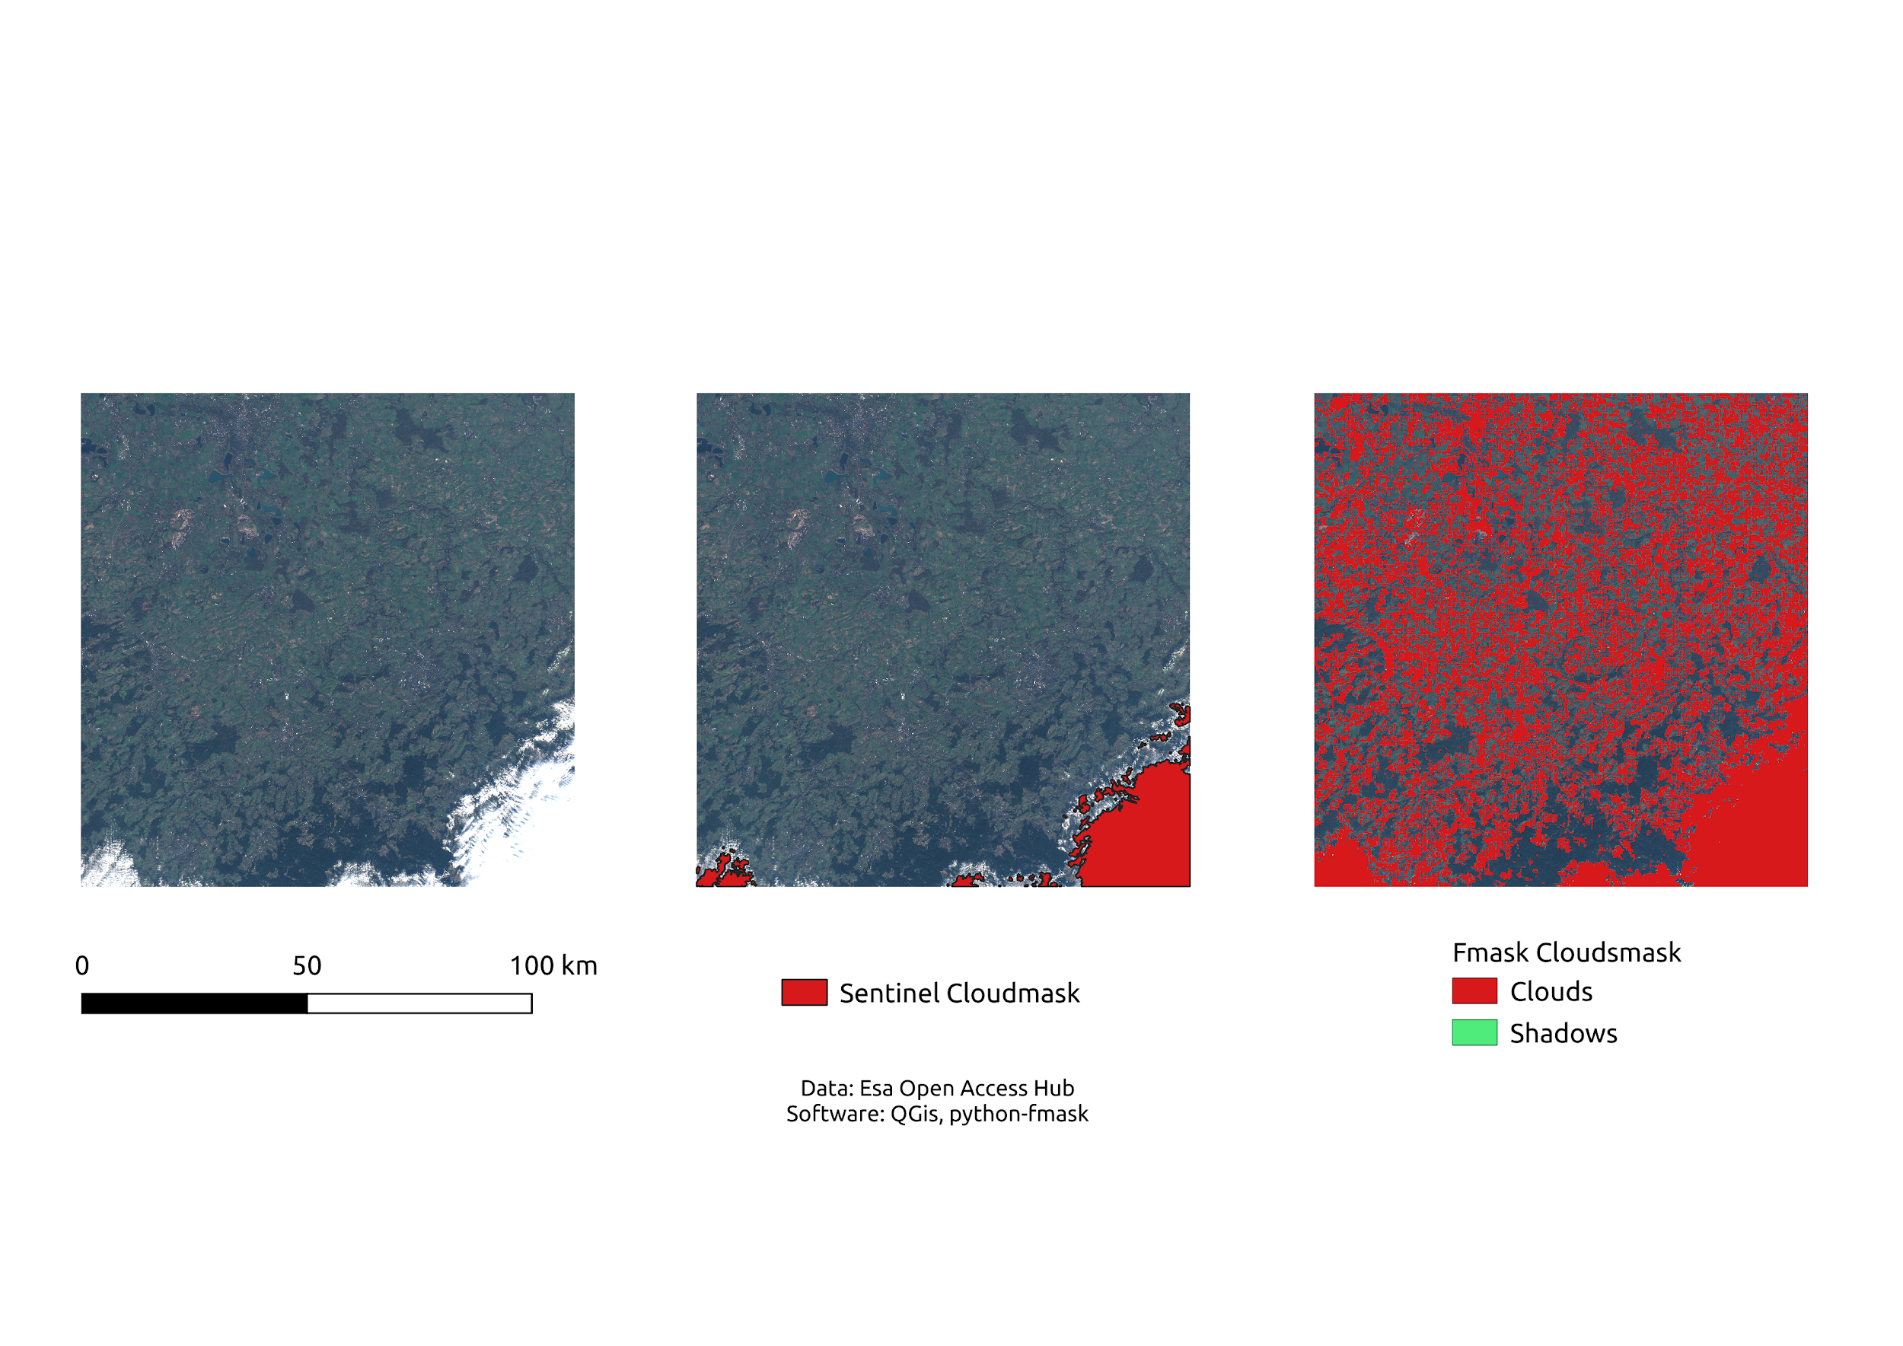

**Fig: 4, Example of potential pitfalls with Fmask-algorithm**

## Import to GRASS

The import of the preprocessed satellite imagery was the first step in our working process that was performed within a PyGRASS script. The i.sentinel add-on in GRASS also provides an import function tailored to Sentinel data however due to the merge our Sentinel scenes were no longer available as .SAFE directories which is the input format for i.sentinel.import. We therefore iterated over our newly created folders containing the merged bands for the 11 dates and each GeoTIFF file was imported to our GRASS GIS project with a generic import command for raster data (r.in.gdal) (see script: *08\_import\_sentinel.py*) The vectorized cloud masks were also imported to GRASS GIS using the generic vector import command v.import (see script: *09\_import\_cloudsmask.py*).

As the following PyGRASS scripts the import script was developed as a GRASS module specifying input and/or output parameters using the GRASS parser which builds a GUI window with user input request once the script is executed within GRASS.

## Creation of Space Time Cubes

GRASS offers different data types for temporal data processing (https://grass.osgeo.org/grass78/manuals/temporalintro.html) . We created a *space time cube* for the Sentinel-2 data as well as the clouds derived by the Fmask algorithm which afterwards served as masks in index calculation.

To create STCs in GRASS each scene has to be linked to its sensing date/time. We stored this information in a text file containing the name of the imagery data and their respective timestamp. This text file was generated using the file names of the data.

The script for creating timestamps (see script: 10\_stc\_timestamps.py) has two input parameters, an output file name and path for both satellite imagery and cloud data timestamp text files.

For the satellite imagery we iterated over all raster data available in the current mapset of GRASS GIS. The name of each raster was divided into chunks using the underscores as separators. Only the item containing date and time information was retrieved and converted to a datetime object. As the temporal information mustn’t be a single point in time but a period we added another timestamp with one second added. Eventually for each scene the whole layer name, start and end date of the time period was annotated to the raster timestamps text file.

For the cloud vector data we again iterated over the raster data, however only over one band per date to retrieve unique dates and select corresponding cloud mask data. All cloud vector files were named *cloudmask\_*sensingdate\_*mergedvector* so subsequently the vector cloud mask for that specific date was detected by looking for a vector layer in the current mapset with the name completed with the date. With the GRASS GIS module r.mask each vector file was converted to a mask that is used to limit raster operations. Each masked was named after the original cloud file and the latter was removed. Again for each mask the whole layer name as well as start and end date of the time period were annotated to a timestamps text file.

The actual creation of a space time data set in GRASS GIS is straightforward and consists of only two commands *t.create* and *t.register*. The first one creates an empty space time dataset of a given name and type, the latter registers the data and assigns timestamps based on the given text file we created beforehand. (script name)

## Multi-temporal index calculation

Vis: Maps with NDVI values (each season and difference Maps also)

Comparison of F-Mask NDVI vs Sentinel NDVI or only Cloudmasks if calculation is too time consuming

Results: NDVI maps

## Web Processing Service

PyWPS is a python-package that implements the Web Processing standard from the Open Geospatial Consortium (OGC). The actual Web Processing Service (WPS) aims the standardization of geospatial processes (Laža, 2018). The Web Processing Service can handle three types of requests that can be asked by a user. These are the *Get Capabilities,* the *Describe Process* and the *Execute* requests. While we won’t dive deeper into the details of PyWPS, it is important to say what a process is, as we tried to implement our own.

According to (Laža, 2018, S:12) a process is: “ [...] just some geospatial operation which has its defined inputs and outputs and which is deployed on a server”. Our goal was to implement a process that takes as input a Space-Time-Datacube (Gebbert, Pebesma 2017) (named STC from here on) of a calculated index. In order to test our small process, the PyWPS-package offers a demo server that is based on the python-package Flask. In terms of python-objects, a process is just a class that needs to be configured in a specific way in order to be a working PyWPS process. Every process for example needs an identifier. In our case we called it simply ndvi as we tested the process with a datacube of ndvi-rasters. However, it could be a STC of rasters with any information. The module *t.rast.series* is an extension, specifically for STCs, of the basic *r.series* module. *The t.rast.series* is capable of aggregating a STC by various algorithms. Moreover, one has the possibility to subset the aggregation in time by using the *where-*option. In order to monitor the differences in an index, one can simply specify two different date-ranges and compare the statistics. That is essentially what our PyWPS-script is intended to do.

# Discussion/Conclusion

As outlined above, the initial aim of creating a GRASS-Gis add-on for the application of the Fmask-algorithm on any Sentinel-2 Level C scene could not be achieved in the way it was planned. While this was quite a disappointment, there were several things we learned throughout the process of this project which can be considered a success.

The software/frameworks used by us can roughly be split up into three parts. The GRASS-Gis part, the pure python part and the PyWPS part which unites the geospatial area with web-development. With the benefits of hindsight we maybe should have given up earlier the GRASS add-on and focussed more on accomplishing the final goal, no matter how. In addition, it potentially would have been good to assign each section to one person that would become an “expert” in the area. As we didn’t do so in the beginning, it became unfeasible in the end.

Still, all the python-scripts we wrote, the setup of a github-repo, the work with GRASS-GIS and PyWps demanded many hours of work. The result, a fairly simple statistic for a range of dates on a Space Time Datacube, does not reflect the amount of effort that was put in there.

* Ordner Pfade müssen bei einigen Skripten immer wieder erneut übergeben werden, könnte man beim nächsten mal noch mehr aneinanderreihen und automatisieren

# References

Čepický, Jáchym. 2007. “PyWPS 2.0.0: The Presence and the Future.” *Geoinformatics FCE CTU* 2 (December): 61–64. <https://doi.org/10.14311/gi.2.8>.

ESA (European Space Agency). n.d. “Long Term Archive (LTA) Access.” *Open Access Hub User Guide*. Accessed July 17, 2020. <https://scihub.copernicus.eu/userguide/LongTermArchive>.

Gebbert, Sören, and Edzer Pebesma. 2017. “The GRASS GIS Temporal Framework.” *International Journal of Geographical Information Science* 31 (7): 1273–92. <https://doi.org/10.1080/13658816.2017.1306862>.

GRASS Development Team. 2019. *GRASS Gis Python Library Documentation*. <https://grass.osgeo.org/grass78/manuals/libpython/index.html>.

GRASS-wiki. 2020. *GRASS and Python*. [https://grasswiki.osgeo.org/wiki/GRASS\_and\_Python#Creating\_Python\_scripts\_that\_call\_GRASS\_functionality\_from\_outside](https://grasswiki.osgeo.org/wiki/GRASS_and_Python" \l "Creating_Python_scripts_that_call_GRASS_functionality_from_outside).

Landa, Martin. 2020. *Jena Grass Gis Workshop*. GISMentors.eu. <https://training.gismentors.eu/grass-gis-workshop-jena/index.html>.

Laza, Adam. 2018. “Process Isolation in Pywps Framework.” Master’s thesis, Czech technical university in Prague - Faculty of Civil engineering. <https://dspace.cvut.cz/bitstream/handle/10467/73987/F1-DP-2018-Laza-Adam-adam-laza-dp-2018.pdf?sequence=-1&isAllowed=y>.

Qiu, Shi, Binbin He, Zhe Zhu, Zhanmang Liao, and Xingwen Quan. 2017. “Improving Fmask Cloud and Cloud Shadow Detection in Mountainous Area for Landsats 48 Images.” *Remote Sensing of Environment* 199 (September): 107–19. <https://doi.org/10.1016/j.rse.2017.07.002>.

Qiu, Shi, Zhe Zhu, and Binbin He. 2019. “Fmask 4.0: Improved Cloud and Cloud Shadow Detection in Landsats 48 and Sentinel-2 Imagery.” *Remote Sensing of Environment* 231 (September): 111205. <https://doi.org/10.1016/j.rse.2019.05.024>.

Tennekes, Martijn. 2018. “tmap: Thematic Maps in R.” *Journal of Statistical Software* 84 (6): 1–39. <https://doi.org/10.18637/jss.v084.i06>.

Zhu, Zhe, Shixiong Wang, and Curtis E. Woodcock. 2015. “Improvement and Expansion of the Fmask Algorithm: Cloud, Cloud Shadow, and Snow Detection for Landsats 47, 8, and Sentinel 2 Images.” *Remote Sensing of Environment* 159 (March): 269–77. <https://doi.org/10.1016/j.rse.2014.12.014>.

Zhu, Zhe, and Curtis E. Woodcock. 2012. “Object-Based Cloud and Cloud Shadow Detection in Landsat Imagery.” *Remote Sensing of Environment* 118 (March): 83–94. <https://doi.org/10.1016/j.rse.2011.10.028>.

# Appendix

|  |  |  |
| --- | --- | --- |
| **Script name** | **Short description** | **Input parameter (in their requested order)** |
| 01\_download\_L2A.py | Filters and downloads Sentinel-2 L2A level data for relative orbit 65 from August 2019 to May 2020 with a cloud cover of up to 10%. | On the command line after script name:  1) Path to geojson file containing AOI boundaries  2) Path to folder for the downloads to be stored  During execution user credentials for Copernicus Open Access Hub are requested. |
| 02\_band8\_crop\_L2A.py | Resamples and moves band 8 to 20m folder. Crops L2A sentinel scenes to AOI while maintaining .SAFE directory structure. | On the command line after script name:  1) Path to folder where the downloaded L2A scenes are stored (as .SAFE directories)  2) Path to shapefile file containing AOI boundaries |
| 03\_merge\_L2A.py | Retrieves cropped L2A scenes from 02\_band8\_crop\_L2A.py and merges the files of corresponding dates. Resulting raster files are then stored in folders named after the respective sensing date. | On the command line after script name:  1) Path to folder where the cropped L2A scenes are stored (as .SAFE directories) |
| 04\_download\_L1C.py | Filters and downloads Sentinel-2 L1C level data for relative orbit 65. Scenes are chosen based on dates of already downloaded (and preprocessed) L2A data. Unzips .SAFE directories. | On the command line after script name:  1) Path to directories with pre-processed L2A scenes (in folders named after sensing date)  2) Path to geojson file containing AOI boundaries  3) Path to folder for the downloads to be stored  During execution user credentials for Copernicus Open Access Hub are requested. |
| 05\_crop\_L1C.py | Crops L1C sentinel scenes to AOI while maintaining .SAFE directory structure. | On the command line after script name:  1) Path to folder where the downloaded L1C scenes are stored (as .SAFE directories)  2) Path to shapefile file containing AOI boundaries |
| 06\_iter\_fmask.py | Applies Fmask algorithm to given .SAFE directories and stores created cloud masks in a new folder. | On the command line after script name:  1) Path to folder where the downloaded (and cropped) L1C scenes are stored as .SAFE directories. |
| 07\_merge\_cloudmasks.py | Converts all cloud masks generated by 06\_iter\_fmask.py to binary raster files keeping only clouds and cloud shadow. Binary rasters are then converted to vector data (geopackage) and cloud masks for the same day are merged to retrieve one cloud mask for the aoi. | On the command line after script name:  1) Path to folder where the cloud masks generated by 06\_iter\_fmask.py are stored |
| 08\_import\_sentinel.py | PyGRASS script to create a GRASS GIS module that imports all raster data generated by 03\_merge\_L2A.py and a vector file of the aoi. | GRASS GIS module requests directory with Sentinel-2 L2A data produced with 03\_merge\_L2A.py and aoi vector file |
| 09\_import\_cloudmask.py | PyGRASS script to create a GRASS GIS module that imports all cloud masks (geopackage files) created with 07\_merge\_cloudmasks.py. | GRASS GIS module requests directory with cloud masks produced with 07\_merge\_cloudmasks.py |
| 10\_stc\_timestamps.py | PyGRASS script to create a GRASS GIS module that creates a timestamp text files for both Sentinel-2 data and cloud masks (based on the current mapset) which are needed to create the space time datasets. Cloud vector data is converted to a GRASS mask and original vector data is removed. | GRASS GIS module requests output text files for both satellite imagery and cloud mask timestamps |

We recommend using an anaconda environment. To apply the Fmask cloud filtering it is mandatory as the python package is only distributed via conda and not available on PyPi.

**Required packages:**

os, sys, sentinelsat, datetime, pandas, numpy, zipfile, shutil, fiona, rasterio, glob, warnings, subprocess, gdal, rios, fmask (only in conda available)